iRing Deployment Resources

Verison 1.0.0 Downloads
- iRINGComponents-100.zip (http://secure.ids-adi.org/repository/org/ids-adi/camelot/Deliverables/iRINGComponents-100.zip)
- iRINGSDKDocumentation.pdf (http://secure.ids-adi.org/repository/org/ids-adi/camelot/Deliverables/iRINGSDKDocumentation.pdf)
- iRINGUserDocumentation.pdf (http://secure.ids-adi.org/repository/org/ids-adi/camelot/Deliverables/iRINGUserDocumentation.pdf)

InterfaceService Prerequisites
- Java SE Runtime Environment 1.6.0_12 (http://www.java.com/en/)
- Joseki SPARQL Endpoint 3.3 (http://sourceforge.net/project/showfiles.php?group_id=71149&package_id=176963)
- MySQL Community Server 5.1.32 (http://dev.mysql.com/downloads/mysql/5.1.html#win32)
- MySQL GUI Tools 5.0 R17 (recommended) (http://dev.mysql.com/downloads/gui-tools/5.0.html)

WCF Services and Silverlight Prerequisites
Windows Server 2003 SP1 (recommended)
- IIS 6.0 with:
  - ASP.NET installed (http://www.microsoft.com/technet/prodtechnol/WindowsServer2003/Library/IIS/01563a60-038c-46d8-9a63-5104f5816767.mspx?mfr=true)
  - ASP.NET 2.0 registered (only do if neccessary) (http://msdn.microsoft.com/en-us/library/k6h9cz8h(VS.80).aspx)
  - Dynamic Content enabled (http://www.microsoft.com/technet/prodtechnol/WindowsServer2003/Library/IIS/a9fc0395-f03b-4213-9c62-1592bcfcf53f.mspx?mfr=true)
- .NET Framework 3.5 SP1 (http://www.microsoft.com/downloads/details.aspx?FamilyID=AB99342F-5D1A-413D-8319-81DA479AB0D7&displaylang=en)
- ADO.NET Entity Framework Provider and approptiate client software for database of your legacy application (e.g. SQLServer workstation components). (http://msdn.microsoft.com/en-us/data/dd363565.aspx)
  - Test Application Requires:
    - SQLite 3.6.11 (select command line tool) (http://www.sqlite.org/download.html)
    - SQLite ADO.NET 2.0 Provider 1.0.60.0 (included) (http://sourceforge.net/project/showfiles.php?group_id=132486)

iRING Interface Service
- LSC: Add this step: Install Java SE Runtime Environment
- Install Joseki into C:\Joseki-3.3 LSC: How is the installation done? Just unzip the file? (i.e., expand zip file to C:\Joseki-3.3). The unzip creates a folder called Joseki-3.3.0 so the result is C:\Joseki-3.3\Joseki-3.3.0. That doesn’t seem right.
- Set JOSEKIROOT environment variable to C:\Joseki-3.3
(Recommended - variation requires a change to %JOSEKIROOT%\webapps\joseki\WEB-INF\web.xml after running mod_joseki)
To set up the environment variable, follow steps below:
  - Open Control Panel and select System.
  - Go to the Advanced tab.
  - Click the Environment Variables button. Select the "new" button for the upper frame to create a new environment variable LSC: System variable or User variable?
  - Enter JOSEKIROOT as the Varible Name and C:\Joseki-3.3 as Variable Value
- Setup an "iring" schema and user account with password "camelot" in MySQL database and provide privileges.
To set up "iring" schema, follow steps below:
  - Go to MySQL Administrator and click on Catalogs.
  - In the window down below, right click and select Create New Schema.
To provide privileges to "iring" schema, follow steps below:
  - Go to MySQL Administrator and click on User Administration.
  - Select iring and assign all the Available priveleges to Assigned Privileges.
  - Click Apply changes.
- LSC: Add this step: Unzip iRINGComponents-100.zip and use the files in the InterfaceService folder as specified in the following steps.
- Run mod_joseki from InterfaceService directory LSC: where does this file exist? From iRing components? When was I instructed to install this?
- From JOSEKIROOT
  - Modify setclasspath.bat according to your environment. LSC: Modify how? Need to be specific.
  - Run setclasspath to configure the java environment for the following commands.
  - Create the default graph in the MySQL database by running dbcreate data. LSC: Located in iRing components? I don’t know if it worked, because it went like a flash. How can you tell if this step succeeded?
  - Create the Interface Service by running create-service. LSC: Located where?
  - Start the Interface Service by running net start josekisvc. LSC: Failed
- Browse the following Uri: http://localhost:2020 LSC: Failed

iRING WCF Services and Silverlight Apps
- Create iRINGWeb folder on appropriate drive on the server.
- Copy AdapterService, MappingEditor, RDSWIPEditor, and ReferenceDataService folders into the iRINGWeb folder.
- Create an application for each subfolder of iRINGWeb from IIS Manager.
  - Select Read and Execute permission.
  - For IRINGFramework and RDSWIPEditor, add "application/x-silverlight-app" MIME Type for .xap file extension.
- Edit AppSettings in each Web.config.
  - AdapterService (http://localhost/AdapterService/Service.svc)
    - CSDLPath - Path of your CSDL file.
    - connectionStrings\add where name="Entities"
(actually not under appSettings.) - This is the Entity Framework connection string. It contains the ADO.NET connection string for your legacy database as well as the location of Entity Framework artifacts, including CSDL file.
  - MappingEditor (http://localhost/MappingEditor) (http://localhost/MappingEditor/Default.aspx)
    - AdapterServiceUri - Base URI of the AdapterService.
    - AdapterProxyCredentialToken - Credential token for AdapterService proxy server.
    - AdapterProxyHost - AdapterService proxy server name.
    - AdapterProxyPort - AdapterService proxy port number.
    - ReferenceDataServiceUri - Base URI of the ReferenceDataService.
    - ReferenceDataProxyCredentialToken - Credential token for ReferenceDataService proxy server.
    - ReferenceDataProxyHost - ReferenceService proxy server name.
    - ReferenceDataProxyPort - ReferenceService proxy port number.
  - RDSWIPEditor (http://localhost/RDSWIPEditor) (http://localhost/RDSWIPEditor/Service.svc)
    - OntologyServiceUri - Base URI of the ReferenceDataService.
  - ReferenceDataService (http://localhost/ReferenceDataService/Service.svc)
    - ClassRegistryBase - URI of the RDSWIP part4 endpoint
(typically http://rdl.rdlfacade.org/data#).
    - TemplateRegistryBase - URI of the RDSWIP part7 endpoint
(typically http://tpl.rdlfacade.org/data#).
    - ProxyCredentialToken - Credential token for ReferenceDataService proxy server.
    - ProxyHost - ReferenceDataService proxy server name.
    - ProxyPort - ReferenceDataService proxy port number.

Installation

Prerequisites

Java SE Runtime Environment
- Download and run the Java SE Runtime Environment 1.6.0_12 or greater located at (http://www.java.com/en/)
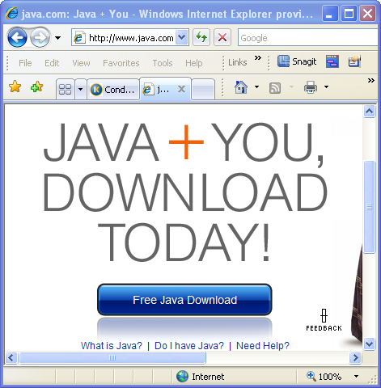

Joseki SPARQL Endpoint 3.3
- Download to a temporary location the file joseki-3.4.0.zip from http://sourceforge.net/project/showfiles.php?group_id=71149&package_id=176963.
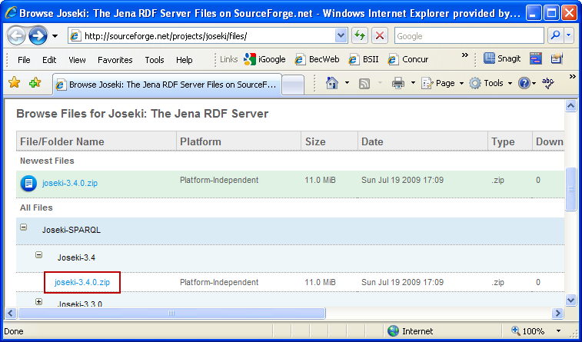
- Extract joseki-3.4.0.zip to the C: drive root directory.
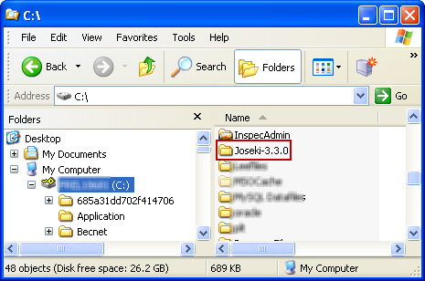
- By default, the folder name is Joseki-3.3.0. Rename the folder to Joseki-3.3.
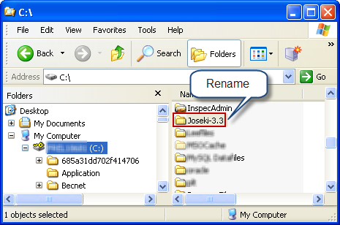
- Final configuration will be done in later in this installation.
- Edit the file “%JOSEKIROOT%\webapps\joseki\WEB-INF\web.xml” and change the string from “C:/Joseki-3.3” to ““%JOSEKIROOT%\”

MySQL Community Server
- Install MySQL Community Server 5.1.32 or greater for Windows located at http://dev.mysql.com/downloads/mysql/5.1.html#win32.
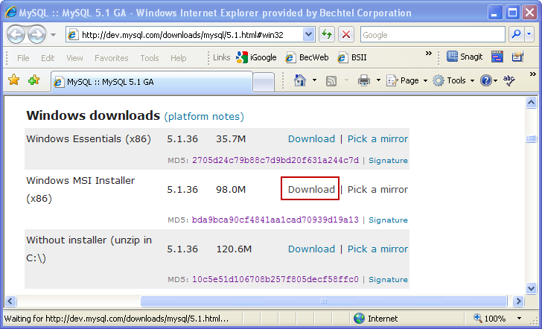
- Run the installation.
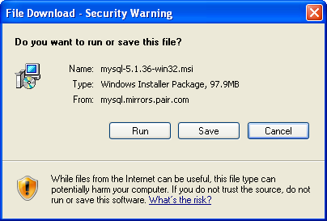

…
STEP 4 – Run mod_joseki from a cmd window to pass the envrioment variables in the batch file
STEP 5a - Needs to be removed
STEP 5b – Run the batchfile
STEP 5c – Run “%JOSEKIROOT%\dbcreate” data from the CMD window. When running this command, if no errors are reported in the cmd window then it is succesful. Then next bring up the MySQL Administrator to verify that the tables are present.
STEP 5d – Create the Interface Service
Before STEP 5e Verify that you are running the correct Java version. To check the Java version run “java –version” from the cmd line. Make sure the version is 1.6.x or higher. If it is not you need to lookup the path and set it at the front of the system path variable. Note: you must reboot the machine to make the path change to apply globally to all services.

STEP 5e – Start the Interface Service – Troubleshooting – If the service does not and there is an error reported, Look at the Windows Event Viewer for a possible hint. If the Event Viewer hint is not revealing anything obovious, then run form the cmd line: bin\rdfserver. Then address each error as the service loads manually. A common error at this stage is Windows Firewall blocking. If that is the case, please select the “Allow” option.
Once the InterfaceService in the console successfuly, test the service by going to http://localhost:2020 in your browser. Once the test is successful, close the cmd window and redo the test as a service. If the there continues to be an error when running as a service, check the “wrapper.log” file located in %JOSEKIROOT%.

iRING WCF Services and Silverlight Apps
Pre install

Install SQL Server Express
Create iRINGWeb folder on appropriate drive on the server.
- Copy AdapterService, MappingEditor, RDSWIPEditor, and ReferenceDataService folders into the iRINGWeb folder.
Verify installation of IIS. Go to Control Panel and open Administrative Tools then open Services. In the Services window you see an service called “World Wide Web Publishing Service” (IIS). If it is not listed ,you must install the service into your computer.
Installing IIS – Go to Control Panel and run “Add or Remove Programs”. Select “Add/Remove Windows Components (located on the rights side of the Add or Remove Programs window).
- Create an application for each subfolder of iRINGWeb from IIS Manager.
  - Select Read and Execute permission.
  - For IRINGFramework and RDSWIPEditor, add "application/x-silverlight-app" MIME Type for .xap file extension.
- Edit AppSettings in each Web.config.
  - AdapterService (http://localhost/AdapterService/Service.svc)
    - CSDLPath - Path of your CSDL file.
    - connectionStrings\add where name="Entities"
(actually not under appSettings.) - This is the Entity Framework connection string. It contains the ADO.NET connection string for your legacy database as well as the location of Entity Framework artifacts, including CSDL file.
  - MappingEditor (http://localhost/MappingEditor) (http://localhost/MappingEditor/Default.aspx)
    - AdapterServiceUri - Base URI of the AdapterService.
    - AdapterProxyCredentialToken - Credential token for AdapterService proxy server.
    - AdapterProxyHost - AdapterService proxy server name.
    - AdapterProxyPort - AdapterService proxy port number.
    - ReferenceDataServiceUri - Base URI of the ReferenceDataService.
    - ReferenceDataProxyCredentialToken - Credential token for ReferenceDataService proxy server.
    - ReferenceDataProxyHost - ReferenceService proxy server name.
    - ReferenceDataProxyPort - ReferenceService proxy port number.
  - RDSWIPEditor (http://localhost/RDSWIPEditor) (http://localhost/RDSWIPEditor/Service.svc)
    - OntologyServiceUri - Base URI of the ReferenceDataService.
  - ReferenceDataService (http://localhost/ReferenceDataService/Service.svc)
    - ClassRegistryBase - URI of the RDSWIP part4 endpoint
(typically http://rdl.rdlfacade.org/data#).
    - TemplateRegistryBase - URI of the RDSWIP part7 endpoint
(typically http://tpl.rdlfacade.org/data#).
    - ProxyCredentialToken - Credential token for ReferenceDataService proxy server.
    - ProxyHost - ReferenceDataService proxy server name.
    - ProxyPort - ReferenceDataService proxy port number

